|  |  |
| --- | --- |
| Course Name | ITD 2263 – Graphical User Interface Development |
| Instructor | Daniel D. Claborn |
| Student Name | Derrick McFall |
| Due date | Nov 05, 2017 11:59 PM |
| Grade | 100% |
| Grading Comments | Derrick,  You did a good job in completing the project.  Please keep up the good work.  Mr. Claborn |

Derrick McFall

Gui

05-Nov-17

* 1. #11-15

11. 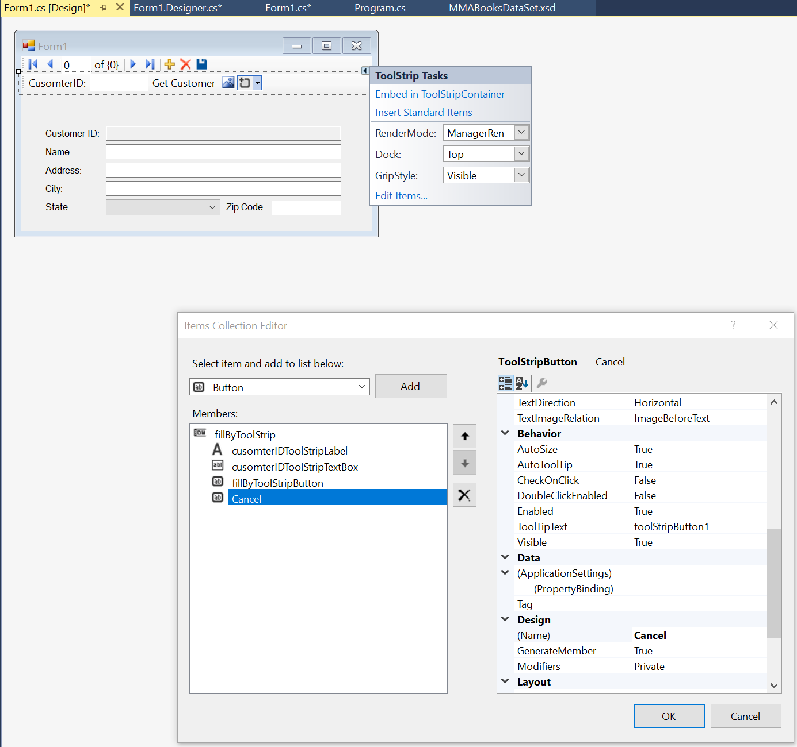

I didn’t have to add any code this was all done through the user interface of Visual studio

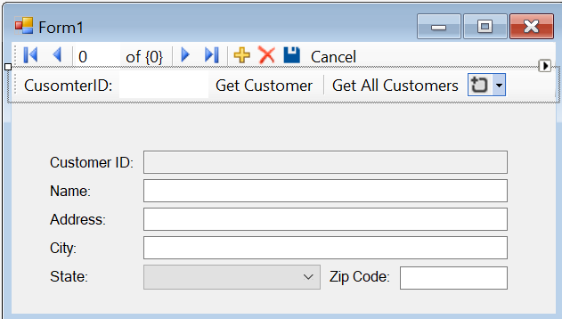

12. as per the book I needed to add one line of code.

private void cancelButton_Click(object sender, EventArgs e)

{

this.customersBindingSource.CancelEdit();

}

12b. The code I added was as suggested from the load event handler.

this.customersTableAdapter.Fill(this.mMABooksDataSet.Customers);

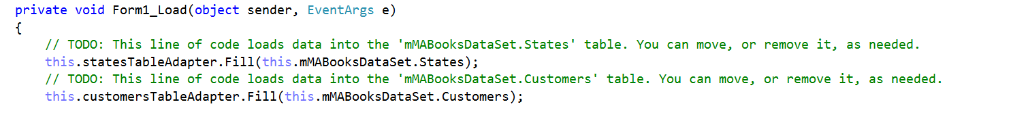

13. Working…

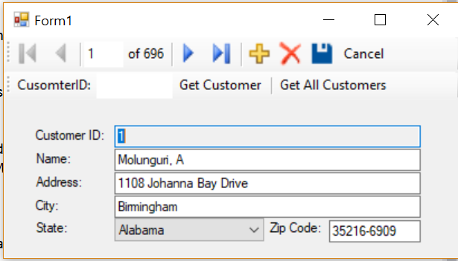

14. I commented out the section in the load event handler that retrieved customer rows.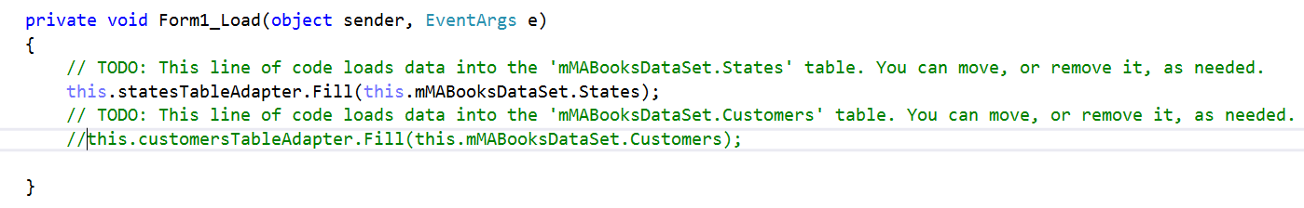

14b. Added the suggest code and statebox shows up not already filled in.

